A random sample of 50 year old men (n=10) was taken. Weight, height, and systolic blood pressure were measured, and BMI was computed. [In this analysis, the independent (or predictor) variable is BMI and the dependent (or outcome) variable is systolic blood pressure (SBP).
Is there an association between BMI (kg/m²) and systolic blood pressure in 50 year old men?
Solution:
The first step is to use R to generate a scatter plot:
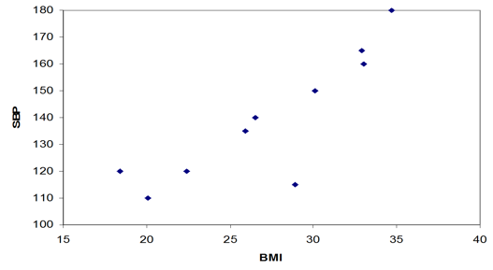
From the scatter plot it appears that there is a reasonably strong linear association.

If we were to evaluate this association using R:

> cor.test(BMI,SBP)
Pearson's product-moment correlation
data: BMI and SBP
t = 4.765, df = 8, p-value = 0.001418
alternative hypothesis: true correlation is not equal to 0
95 percent confidence interval:
0.5021885 0.9663408
sample estimates:
cor
0.8599168

This indicates a strong, statistically significant relationship between BMI and systolic blood pressure. The correlation coefficient, r = 0.86, 95% CI for r (0.50, 0.97), p=0.0014.

